**SPRINT-2**

|  |  |
| --- | --- |
| **Team ID** | PNT2022TMID51289 |
| **Project Name** | SMART SOLUTIONS FOR RAILWAYS |

**PROCEDURE:**

Step1: Develop node red web application for train ticket booking

Step2: Copy the node red link and add /ui to the same link and browse it Step3: Fill the details

Step4: Click on submit

Step5: QR code will be submitted

Step5: Ticket is generated

**NODE RED FLOW CONNECTION:**

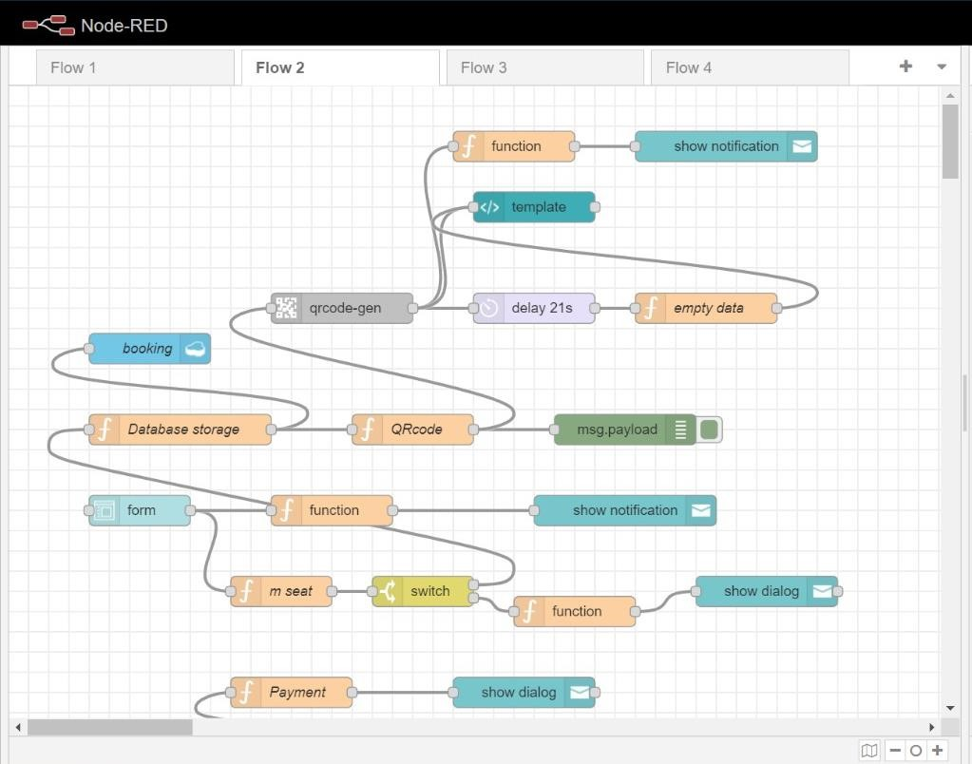

**NODE RED FLOW FOR PAYMENT:**

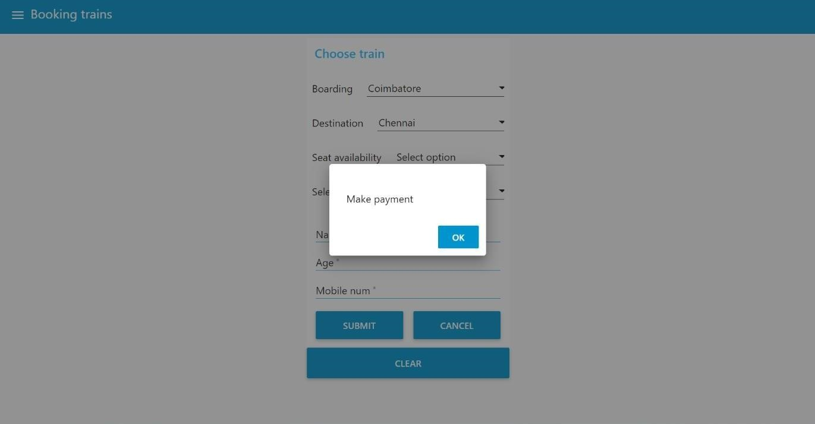

**PAYMENT PAGE:**

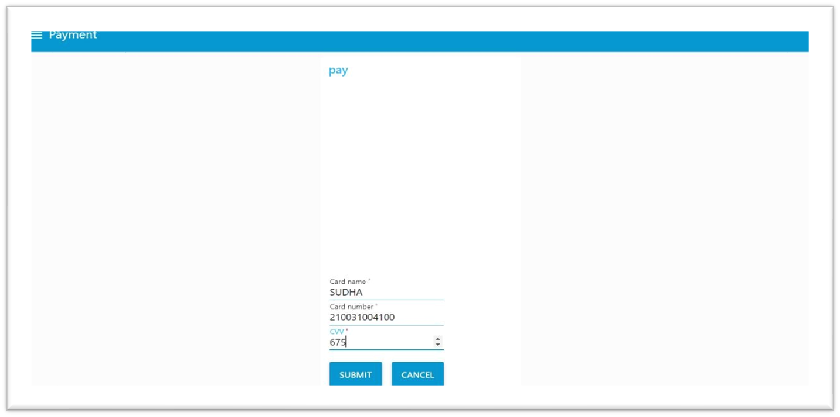

**QRCODE GENERATION:**

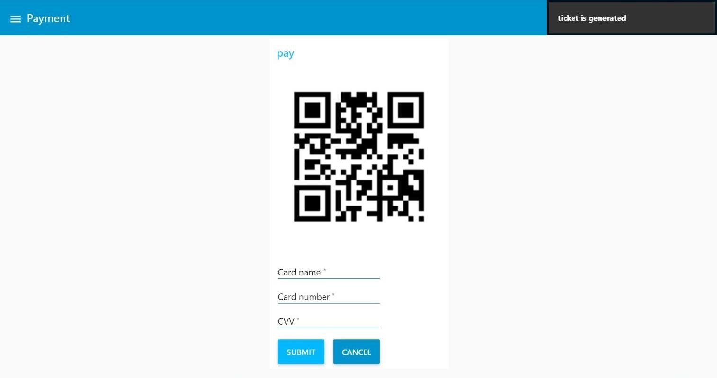

**NODE RED OUTPUT:**

